**Comparing colony productivity and pathogen infection between California-bred and New England-bred honey bees (*Apis mellifera)***

Andre J. Burnham1*, Fiona McLaughlin1, Phillip A. Burnham2, & Herman K. Lehman1

*1Department of Biology, Hamilton College, Clinton, United States*

*2Department of Biology, University of Vermont, Burlington, United States*

*\*Author for correspondence (aburnham@hamilton.edu)*

**ABSTRACT**

Honey bees (*Apis mellifera*) are global pollinators that have been on the decline due to various environmental and pathogen-related factors. Recent studies have suggested that environmental adaptations in honey bee phenotypes could be tied to colony productivity. However, differences in pathogen infection between different colony ecotypes have been less studied. Here, we test the null hypothesis that queen bee ecotypes from very contrasting climates produce offspring that are equally productive and resistant to pathogens when observed in the same geographical region. We demonstrate that local colonies grew significantly more in total biomass than Californian colonies did. Locally-raised bees also reared significantly more brood. In assessing resistance to parasites and pathogens, we found no significant differenceover time in levels of *Varroa destructor*. Using semi-quantitative PCR to evaluate levels of deformed wing virus (DWV), black queen cell virus, (BQCV), and Israeli acute paralysis virus (IAPV), we observe that levels of BQCV and IAPV were unaffected by treatment. However, our results show a significant interacting through time in DWV infection. *Nosema* *sp*. loads significantly decreased in local bees, while spore loads in the Californian colonies increased. To our knowledge, this is the first study to demonstrate differences in *Nosema sp.* infections between different honey bee ecotypes. Our data suggest that locally-raised bees from the Northeast have increased immune response function and are more productive in native regions when compared to queens and workers from other climates. Such environmental adaptions relating to these factors could be tied to future honey bee sustainability.

Key Words: Ecotypes, *Nosema ceranae*, environmental adaptations, fitness, requeen

**INTRODUCTION**

The honey bee (*Apis mellifera*) is responsible for the pollination of many different crops necessary for agricultural sustainability. In 2009, the worldwide economic value of honey bees was estimated to be $172 billion (Gallai et al. 2009). However, these ever-important pollinators have been in steady decline for the past several decades, and with the rise of Colony Collapse Disorder (CCD) in 2006-2007, colony losses have been even greater for commercial and hobbyist beekeepers (Vanengelsdorp et al. 2008). There has been much debate as to the causation of this severe collapse in honey bee populations. RNA viruses, parasites, bacterial and fungal infections, pesticides, and migratory stress have all been thought to contribute to honey bee’s decline as well as CCD (Pettis and Delaplane 2010, vanEngelsdorp et al. 2009). However, colony fitness, as determined by local environmental adaptations and queen bee genotypes, may also be a contributing factor to the survivability and productivity of honey bee colonies throughout different geographical regions (Costa et al. 2012).

During their mating flights, virgin queens usually breed with 7-17 drones, which improves genetic diversity and overall survivorship (Adams et al. 1977, Tarpy et al. 2013). Upon its return to the hive, the fertile queen’s ovaries become activated, producing up to two thousand eggs a day (Root 1910). Because the queen becomes the only reproducing female in the colony, the genotypes of queen bees and the drones they breed with dictate the genotype of every worker bee in the colony (Tarpy et al. 2013). Consequentially, queen bee genomes are partly responsible for expression of behavioral and physiological traits in worker bees.

oragers that cEpigenetic theories suggest that species can inherit phenotypic alterations influenced by specific environmental interactions over extended periods of time (Holliday 2006). In accordance with these concepts, beekeepers and researchers alike are beginning to find that local honey bee stock may have certain fitness advantages (behavioral and phenotypical) over imported bees that have been bred in climatically and ecologically different environments (Costa et al. 2012, Szabo and Lefkovitch 1987). Such advantages may be related to nectar and pollen foraging behavior influenced by climatic differences in daytime temperatures and relative humidity (Gebremedhn et al. 2014). Other fitness factors may be guided by resistance to pathogen strains that are be less prevalent in the imported animals’ original region (Brutscher et al. 2015). This concept of locally adapted strains of honey bees is both biologically and agriculturally relevant because many beekeepers purchase queens from California and other warmer regions where queen cells can be produced almost year round.

There has also been recent evidence that honey bee-environmental interactions may relate to colony fitness on the molecular and cellular level, where expression of mitochondrial-related proteins and immune genes are different between ecotypes (Parker et al. 2010). Together, these studies suggest that local environmental adaptations over several generations in honey bees influence foraging behavior preferable to a northern climate and expression of proteins associated with energy production and the immune response. Such factors are heritable and a product of local queen and drone genotypes.

Our null hypothesis for this study was that the offspring of locally raised queens from the Northeast are equally adapted for survival and productivity in this region as compared to queens and worker bees from California. We chose California-raised animals for the second group because this climate is much different from that of the northeast. Factors related to colony survivorship include collection of nectar and pollen, brood rearing, and resistance to parasites and pathogens. To test this hypothesis, we examined these factors, choosing five of the most common and relevant pathogens and parasites in honey bees. The measures that we specifically chose for the productivity/foragability component of this experiment were colony growth, weight of pollen collected from each hive, and the population of brood in each hive.

The pathogens and parasites that we measured were the ectoparasite varroa mites (*Varroa destructor)*, *Nosema sp*., and three of the most common RNA viruses – deformed wing virus (DWV), black queen cell virus (BQCV), and Israeli acute paralysis virus (IAPV). These viruses can have morphological symptoms on the host (crippled wings and darkened larvae for DWV and BQCV respectively), but on a cellular level, IAPV has been shown to lower mitochondrial activity (de Miranda and Genersch 2010, Chen et al. 2014). Honey bee viruses have been linked to lethal damages on the colony level, and a colony that is more immune to these viral infections would be more productive and have much better chance at survival (Berthoud et al. 2010).

The two species of *Nosema* found in honey bees are *N. ceranae* and *N. apis*. While both species are similar in that they infect the ventriclulous of the host animal*, N. ceranae*, the most prevalent of the two spores, is also the most lethal (Klee et al. 2007, Higes et al. 2006). Adult workers can die after just eight days of exposure, and nosemosis can cause reductions in colony size as well as reduce nectar collection (Botias et al. 2013, Malone et al. 1995, Higes et al. 2007). Other studies have demonstrated that *N. ceranae* induce immunosuppression of particular immune genes in infected animals, which could also increase susceptibility to other pathogen infections (Antúnez et al. 2009, Chaimanee et al. 2012). Strains of honey bees that are less susceptible to this infection and have heightened expression of these immune genes would be more fit for survival where the disease is prevalent. In general, this concept of localized immunity was largely applied to our study, where we examined worker bee pathogen loads in connection with the geographical origin of queen bees.

**MATERIALS AND METHODS**

**Selecting & Requeening Colonies**

We selected forty honey bee colonies at random from a Central New York apiary of over one hundred 8-frame single story Langstroth hives. The forty colonies were dequeened on 30 May 2016. On the same day, we equalized the hives by exchanging frames of brood where necessary. The majority of the colonies had 4 full frames of brood while only a four hives were given three. The population size of each colony was also equalized at the start of the study. Three days later, the hives were then moved to our experimental sites in two of the colony owner’s mating yards – 20 colonies in each yard. The hives were left on pallets for the remainder of the study. After the colonies had been queen less for a total of 4 days, we requeened 10 colonies in each yard with Carniolan-derived queens (*Apis mellifera carnica*) bought from one of the largest queen breeders in California and 10 colonies in each yard with our “local” Carniolan-type queens shipped in from a reputable Vermont queen breeder. We labeled the hives using a using a letter/number format, with Y + number indicating the yard number and C/L + number indicating whether the hive was Californian (C) or Local (L). Because the colonies had been queen less for four days due to a weather delay, we shook off all of the bees on every frame and cut out any started queen cells before requeening. On 8 June 16 (five days after requeening), we checked on all of the colonies and found that all but two of the hives had a laying queen – one in each yard. We put new Californian queens in Y1C1 and Y2C5. Y1C1 accepted the new queen. Y2C5 did not accept the second queen and was dropped from the study as a consequence.

**Weighing Colonies & Determining Relative Growth**

We made 4 weight measurements of the colonies – one before the new queens’ offspring had hatched in order to establish a starting weight (14 June 2016) and 3 other measurements to establish change in weight over time after the treatment. We weighed the colonies by placing each hive body and super on top of a digital scale mounted on a plywood stand. The scale was accurate to 0.2 pounds. These measurements took the total colony weight into consideration, including the weight of the boxes and frames. As a result, we also subtracted the average weight of an empty box to find a more accurate representation of colony weight (bees, brood, honey/nectar, pollen, and comb).

**Measuring Pollen Collection**

Using pollen traps is a standard method for collecting pollen and evaluating productivity of forager bees (Delaplane et al. 2013). Ten-frame Betterbee® plastic pollen traps were adapted for 8-frame Langstroth hives by screwing a small pine board to the side of the device. The traps were advertised as collecting less then 50% of the pollen from foragers entering the hive. While the exact percent of pollen removed by the traps was unknown, we were only looking for a consistent amount of pollen collected by the hives so that we could evaluate relative forager productivity between the local and Californian groups.

For each measurement, the traps were left closed for 24 hours once a week, starting on 14 June 2016. We closed the traps and collected pollen from each hive after the 24-hour trapping period. In order to consistently remove the moisture from the samples, we then put each sample of pollen collected into tared glass dishes and heated them in a drying oven for 24 hours at 45-50 oC. Each pollen sample was finally individually weighed.

**Counting Brood Combs**

The amount of brood present in each colony was estimated by periodically counting frames of brood. Because this standard method is somewhat subjective, we counted frames that were ≥ ¾ full as “full frames.” Those that contained less were added together with other < ¾ frames to equal one frame of brood. A similar was method used in another study (Tarpy and Seeley 2006). The starting number of brood combs was three to four in each colony on 30 May 2016. We counted brood on four other time steps.

**Determining levels of *Varroa destructor***

Varroa mite levels were evaluated four times throughout the duration of the experiment using the “powder sugar method” on a mite per 300 bee metric (Dietemann et al. 2013). One quarter cup of bees (about 300 bees) was sampled from the brood chamber of each hive and put into a screened mason jar. We then let the bees sit for 60 seconds in the jar after dropping 1 tablespoon of powdered sugar on top of them. Jars were shaken over a white plate that was protected from the wind in shielded chamber until the sugar and/or mites stopped falling – about 30 seconds. Dissolving the sugar with a water spray bottle allowed us to easily count the mites on the white background, giving us a mite/300 bee ratio for each colony. Equipment was disinfected in-between each colony sampling. The owner of the colonies treated for varroa mites after the first mite count on 15 June 2016 using 75 mL of 1.11 specific gravity formic acid, significantly bringing down the average mite count for each yard.

**Quantifying *Nosema* Spores**

One quarter cup samples of foragers were taken from each hive at three different intervals throughout the study: before the experimental queens’ offspring started hatching (16 June 2016) and two times after new bees had been hatching for several weeks (19 July 2016 and 9 August 2016). Since *Nosema* spore infections are most present in foragers, we collected bees from peripheral combs containing fresh nectar and pollen (Botias et al. 2013, Higes et al. 2008).

We then counted out fifty whole bees from each sample and homogenized the abdomens with a pestle in 50 mL of distilled water for 1 min (Cantwell 1970). Each sample was then loaded into both wells of a hemocytometer where we counted all the *Nosema* spores in the center and corner squares of the middle grid under phase-contrast light microscopy (x400) – a standard method (Cantwell 1970). We were finally able to calculate the number of spores per bee for each sample (Cantwell 1970). It should also be noted that we were unable to tell the difference between *Nosema apis* and *Nosema ceranae* using this method, as the two species are very similar in appearance under light microscopy.

**Quantifying RNA Viruses Using PCR**

We determined the presence of DWV, BQCV, IAPV in each colony using semi-quantitative PCR. Fifty-bee samples were collected from the brood chamber of each hive twice throughout the study – one sample before the experimental queens’ offspring had hatched (15 June 2016) and one sample after the new bees had been hatching for 15-19 days (13 July 2016).

All samples were stored on –80 oC until RNA extraction. We extracted and purified RNA using a modified version of the National Honey Bee Survey’s (NHBS) Protocol-04.Reverse transcriptase and reagents from GoScript (random primers) were used to convert our RNA to a cDNA. After cDNA synthesis, we ran each sample through a 35-cycle polymerase chain reaction using GoTaq® and USDA primers for DWV, BQCV, IAPV andhoney bee actin (Table 1). Because IDT’s suggested annealing temperatures were significantly different for each primer, we ran each virus in a different gel under different PCR conditions (Table 1). We used nucleotide sequences of each primer amplicon (manufactured by G-Block®) for positive controls. Gel electrophoresis was used to analyze our PCR products. The intensity levels (volumes) of each PCR product were evaluated against the corresponding actin genes to give us a quantifiable level of each colony’s viral infection level.

**RESULTS**

**Colony Productivity**

We found no significance in pollen collection in local and Californian colonies with treatment (Fig. 1). However, we observed significant differences in total brood present between local and Californian colonies following T1 (Fig. 2). The first time step was measured on 30 May 2016, four days before we requeened the colonies on 3 June 2016. T2 (p=0.021) showed a significant increase in the number of local frames of brood (Fig. 2). Varroa mites were treated for using formic acid between T2 and T3 on 18 June 2016. The measurement following the formic acid treatment showed a decrease the brood in both colony groups T3 (p=0.155). Two more measurements were taken; T4 (p=0.0032) and T5 (p=0.00980), indicating significant differences in local colony brood nest growth. Each consecutive time step following T1 for local colonies yielded a p-value < 0.05 (T2; p=0.0004, T3; p=0.00000001, T4; p=0.0001, T5; p=0.035). None of the sequential time steps for the Californian colonies resulted in significant p-values (T2; p=0.339, T3; p=0.107, T4; p=0.470, T5; p=0.072).

The total average colony biomass (excluding equipment weight) was measured at T1 (p=0.121) for both local and Californian colonies, 11 days after we requeened. This variable evaluates the total mass of each colony, including bees, brood, nectar, honey, pollen, and wax. The average weight for local hives at this starting point was 25.21 lb, while that of the Californian hives was 23.43 lb (Fig. 2). T2 showed a trend favoring the local colonies, p=0.0047 (Fig. 2). T3 continued this trend with little significance, however (p=0.28). The final time step, T4, followed the same pattern and trended towards significance (p=0.072).

**Levels of Parasites and Pathogens**

Of the four time steps in counting varroa mites on a mite per 300-bee metric, we found no significant differences between local and Californian colony levels (data not shown). However, these data could have been skewed on account of treating for varroa mites between T1 and T2, as this caused the varroa mite levels in both groups to severally drop from T1 to T2.

RNA extraction of 50-bee samples demonstrated high quality and yield of RNA (data not shown) that could be successfully amplified after cDNA synthesis using conventional PCR. Our PCR results showed consistent band intensity for actin as well as positive control amplicons (Gblocks®) of DWV, BQCV, and IAPV*.* Severallanes on our PCR gels showed products out of our target range for BQC and IAPV, suggesting primers randomly binding to nucleotide sequenced on our cDNA.

Our PCR results for cDNA samples of BQCV showed no significant differences in pathogens levels at the second time step (p=0.17), although there was an increase from the first time step. T1, however, demonstrated an uneven starting level for both pathogens (p=0.006). Levels of IAPV did indeed differ between both time steps in local and Californian colonies (p=0.006), but the infection levels themselves remained constant through both time steps in Californian and local colonies (p=0.127 and p=0.186 respectively), which suggests no change in viral infection from the start of the experiment. We did, however, find trending significant differences in levels of DWV loads at T2 (p=0.051) and a significant interaction through time (p=0.0316; Fig. 3). The volumes of DWV were homogenous 12 days after requeening at T1, indicating an even starting point (Fig. 3). At T2, forty days after requeening, local colonies were less infected than Californian colonies (Fig. 3).

Quantification of *Nosema* spore loads demonstrated significant decreases in local colony infection and increases in California colony infections over time (Fig. 4). T1 was sampled on 16 June 2016, 13 days after requeening. This initial time step (p=0.266) ensured that we were sampling foragers produced by the original queen. T2 (p=0.0029) on day 47 showed significant differences in spore loads between local and Californian foragers. The trend suggests that local colonies had lowered their spore loads from T1 to T2 (p=0.074), while Californian colonies had a significant increase in spore loads from T1 to T2 (p=0.014) (Fig. 4). The third time step (T3) on day 68 again showed a significant difference in local and Californian forager spore loads (p=0.00000133) (Fig. 4). The local colony trend of decreasing spore loads in T3 was consistent with T2. From T1 to T3 local colony spore levels significantly decreased (p=0.011) (Fig. 4). Californian and local colony spore levels were relatively unchanged from and T2 to T3, respectively p=0.175 and p=0.0675 (Fig. 4). Californian spore loads followed this trend from T1 to T3 (p=0.0635) (Fig. 4).

**DISCUSSION**

**Changes in Sample Size and Response to Formic Acid Stressor**

On account of the formic acid treatment for varroa mites initiated by the apiary owner, several of the colonies became queen less or extremely week and had to be dropped from the study (Table 2). Several of the colonies were also equalized by adding frames of brood at the owner’s request. These colonies were also dropped accordingly from productivity analysis on account of inevitable interference with colony weight and pollen collection behavior. However, some these colonies were still viable for immediate *Nosema* *sp*. and virus sampling (Table 2). All equalized colonies were eventually completely removed from the population due to the introduction of hatching workers unrelated to our experimental queens.

The general trend of our data demonstrates that colonies requeened with local queens were more productive and disease-resistant than those of Californian origin. Moreover, our results show a much higher recovery in terms of colony growth and brood population after the formic acid treatment (Fig. 2). These results strongly suggest that the local bees may have responded better to this stressor. Bees that are better able to tolerate the stressors of a formic acid are likely more desirably on an agricultural level, especially since formic acid a common commercial treatment for varroa mites.

**Factors Limiting Colony Productivity**

Local colonies significantly increased more in total biomass over time than the Californian colonies (Fig 2). Our results also suggest that local colonies reared significantly more brood (Fig. 2). Although the data we collected for efficiency of pollen foraging do not seem to present any correlations between queen origin and productivity (Fig. 1), our brood population and colony growth results indicate that offspring of locally-reared queens are more productive overall at foraging for nectar and rearing brood in their native environment. These same data suggest that the queens themselves could have been more prolific egg layers as well.

The presence of young larvae and open brood is one of the main factors that limits pollen foraging behavior in honey bees, as this stage in the brood cycle requires a constant supply of pollen and nectar feeding by the nurse bees (Dreller et al. 1999, Free 1967). Given this information, we would have predicted a significant increase in pollen foraging in the local colonies on accounted of the higher brood population. However, this was not observed (Fig. 1). While our weekly 24-hour sampling method might not have been an affective determinant of pollen productivity, studies have shown that the presence of a queen and/or queen mandibular pheromone increases the ratio of pollen foragers to nectar foragers (Free 1967, Higo et al. 1992). It is possible, therefore, that the Californian queens produced higher levels of queen mandibular pheromone, stimulating a higher proportion of pollen foragers despite the smaller brood area found in Californian colonies. This same concept could partially account for the significant difference in colony weight between the two groups, since the ratio of nectar foragers increases in colonies without a queen and possibly low pheromone levels (Free 1967). The genetic structure within a colony has also be demonstrated to influence the division of labor between nectar and pollen foragers (Robinson and Page 1989). Our local colonies could have been more programed to forage for nectar than pollen, which would also account for increased colony weight over time (Fig. 2).

Despite the limiting factors that have been identified in foraging behavior, perhaps the most relevant explanation for the significant changes in colony weight favoring local colonies is tied to the increased infection of *Nosema sp*. that we found in the Californian colonies (Fig. 4). Foragers usually have higher *Nosema* spore loads than house and nurse bees (Botias et al. 2013, Higes et al. 2008). Not only does this microspore decrease the lifespan of its host, but it also has been found to impair flight activity (Ding 2010). In one study, foragers infected with *Nosema* took significantly longer to return to their colony when compared with uninfected bees, and 19.0% of the inoculated bees never returned, compared to only 6.9% of the non-inoculated bees (Kralj and Fuchs 2010). If foragers become disoriented in this fashion when infected with *Nosema*, there is a strong possibility that the colony will not collect as much nectar, and will thus grow less overall. These results, in conjunction with our own, present a correlation between foragers infected with *Nosema* and colony foraging productivity, as determined by overall growth (Fig. 2).

**Heightened Immune Gene Expression in Response to *Nosema* Infection**

Our results strongly suggest that colonies with genetic origins to the Northeast are more immune to *Nosema sp.* than are bees bred in the western U.S. (Fig. 4). However, this work only supports the correlation of locally bred honey bees with lessened *Nosema* *sp.* loads. Other studies have identified antibacterial peptides and other genes related to the immune response that are suppressed after inoculation of *N. ceranae* (Antúnez et al. 2009, Chaimanee et al. 2012). Current research shows that 3 to 7 days after inoculation of *N. ceranae*,significant suppression of abaecin, hymenoptaecin, defensin and glucose dehydrogensase (GLD) occurs (Antúnez et al. 2009, Chaimanee et al. 2012). Together these genes are partially responsible for innate immunity in insects (Antúnez et al. 2009). Honey bee vitellogenin (Vg) expression is another factor to consider after infection of this microspore.

GLD is required by the cellular response during the encapsulation reaction and the killing response of fungal pathogens (Antúnez et al. 2009). There is even evidence that GLD may be responsible for activation of the cellular immune response by acting as a marker gene (Lovallo and Cox-Foster 1999). Humoral immunity in insects, on the other hand, is facilitated by a collection of antibacterial peptides, which are synthesized in response to fungal and bacterial invasion (Hetru et al. 1998, Lamperty et al. 1999, Yamauchi 2001, Klaudiny et al. 2005). Abaecin, defensin, and hymenoptaecin are three of these previously identified antibacterial peptides in the honey bee immune response (Casteels, et al. 1989, 1990, 1993, Casteels-Jonsson et al. 1994). Given the clear importance of these three immune genes to the honey bee’s cellular and humoral response, suppression could be responsible for decreased lifespan after infection of this miscrosporidian. This implies that higher expression of these specific immune genes after infection with *Nosema* could cause a stronger immune response to invasion of this pathogen and even combat invasion/infection of other pathogens (such as BQCV, DWV, and IAPV). It is possible, therefore, that our northern-bred bees had higher immune gene expression, a product of genetic diversity and environmental adaptations that alter protein expression profiles.

There has also been evidence that *N. ceranae* inoculation causes suppression of Vg (Antúnez et al. 2009, Chaimanee et al. 2012). Although not an immune gene, Vg, a yolk precursor protein, is synthesized in abdomen fat bodies and associated with foraging behavior in worker bees (Ihle et al. 2015). It has been suggested that Vg expression is correlated with resistance to oxidative stress, and as a result, increased lifespan in workers and queens. (Nelson et al. 2007). Higher expression in local colonies of this protein after infection, therefore, would also imply an increase in colony strength, fitness as well as individual bee lifespans.

**Immune Response to Viral Infections**

Local colonies maintained a lower expression level of DWV than the Californian colonies in an interactive response to time, possibly indicating a stronger immune response to this virus in favor of individuals of local (northern) origin (Fig. 3). The honey bee immune response to viral infections, therefore, could be another strategy in analyzing our results. Recent studies have suggested that RNA interference (RNAi) is the greatest antiviral innate immune response in insect immune systems (Ding 2010, Flenniken et al. 2010, Ding and Voinnet 2007, Wang et al. 2006, Zambon et al. 2006). The lower infection levels of DWV that we observed in local colonies (Fig. 3) could partly be a result of increased expression of proteins involved in the RNAi pathway, such as dicer enzymes, a Drosha homologue and other elements of the RNA Induced Silencing Complex (RISC) (Weinstock et al. 2006).

**Genetic Diversity in Pathogen Strains**

Genetic variations of pathogen species based on geographical region could play a role in the lower *Nosema* and DWV infections that we observed in locally-adapted colonies (Figs. 3-4). Several recent works have identified isolates in the *Nosema* genome that differed by geographical region, revealing variations in strains that could point to variations in virulence (Dussaubat et al. 2013, Chen et al. 2009) Variations in viral genomes of BQC, DWV, IAPV, among other honey bee RNA viruses, have also been observed in different environments (Yang et al. 2013, Palacios et al. 2008, Chen et al. 2014). In particular, several variations of DWV have recently been found in Asian honey bees (Yang et al. 2013). These data complement our own and suggest that heterogeneous pathogens that vary between geographical regions could eventually influence virulence on account of localized immune adaptations. In regard to our study, the lower levels of *Nosema sp*. and DWV that we observed in local colonies could be connected to genetic diversity in both honey bees as well as the pathogens themselves. Despite this, further research is needed in order to conclude whether virulence of these specific strains of pathogens is dictated by genotypic variations.

**Protein Expression Profiles Determined by Environmental Adaptations**

The present work demonstrates that colonies had significant improvements in growth, brood production, and *Nosema, sp*. resistance after being requeened with local queens, while colonies requeened with queens of Californian origin showed less productivity and less resistance (figs. 2-4). Current research is suggesting that even in the midst of a very commercialized beekeeping industry, environmental interactions that improve productivity and even survivability still occur in strains of honey bees (Costa et al. 2012, Buechler et al. 2014). A recent project in Italy involved the relocation and introduction of Italian honey bees (*Apis mellifera linguistica*)queens from three different regions of differing climates (Costa et al. 2012). A significant difference in honey production was observed favoring queens that were native to experimental sites (Costa et al. 2012). Moreover, morphological differences that favor honey production in geographically diverse populations honey bees have also been observed (Szabo and Lefkovitch 1987). These data supplement our own and suggest that behavioral and morphological traits that favor productivity in given regions are involved with environmental interactions, such as weather, food source, and native pathogen-related interactions. These studies provide further rationales for the superior growth in the local colonies that we observed, as the vast majority of our colony weights were probably accounted for by honey mass (Fig. 2.) On a molecular level, these correlative data might further be explained by examining environmental interactions along with protein expression profiles, especially the prevalence of mitochondrial-related proteins.

Mitochondria, as the cell’s primary synthesizers of ATP, should show increased colony fitness and overall productivity with increased activation in individual animals. Increased energy in a cell results in increased cellular function. Researchers studied honey bees from Saskatchewan (Canada), NZ, Hawaii, California, and Chili and compared various protein expression. In general, protein expression profiles were similar throughout colonies of similar geographical origin and varied in colonies from regions of contrasting latitudes/climates (Parker et al. 2010). Expression of proteins related to mitochondrial function and ATP synthesis, including cytochrome c oxidase and reductase, a citrate synthase, transaldolase and 6-phosphogluconolactonase, was consistently higher in the northern (Canadian) bees than the Californian animals (Parker et al. 2010). Conversely, Californian populations showed significant down-regulation in ATP synthase β and δ subunits, cytochrome C oxidases, NADH dehydrogenases and malate dehydrogenase (other mitochondria-related proteins) (Parker et al. 2010). This same study, however, showed that proteins involved in capacity of protein metabolism were up-regulated in warmer regions, suggesting that protein expression in honey bees can be influenced by local adaptations that favor a given climate or ecosystem (Parker et al. 2010). These findings strongly agree with our own observations and potentially account for increased colony/queen productivity and resistance to *Nosema*, as most cells, including immune cells, require a constant supply of ATP (Coyne 2011).

Overall, our results present evidence that offspring of locally raised queens from the Northeast have better adapted for survival and productivity in northern regions as compared to queens and worker bees from California, a climatically contrasting environment. Because we demonstrate that these environmental adaptions may ultimately be connected to resistance to *Nosema sp*., DWV, and potentially other pathogens, future colony survivability and agricultural sustainability could be impacted by the commercial migration of honey bee ecotypes.

**Table 1** Primers used for the amplification of RNA viral amplicons and *Apis mellifera* actin gene.

|  |  |  |  |  |
| --- | --- | --- | --- | --- |
| Primer | 5’ to 3’ Sequence | Product Size (bp) | Annealing Temp (oC) | Reference |
| DWV-F | TTCATTAAAGCCACCTGGAACATC | 136 | 53 | vanEngelsdorp and Evans et al. 2009 |
| DWV-R | TTTCCTCATTAACTGTGTCGTTGA |  |  |  |
| BQCV-F | TTTAGAGCGAATTCGGAAACA | 140 | 51 | vanEngelsdorp and Evans et al. 2009 |
| BQCV-R | GGCGTACCGATAAAGATGGA |  |  |  |
| IAPV-F | CCATGCCTGGCGATTCAC | 203 | 47 | vanEngelsdorp and Evans et al. 2009 |
| IAPV-R | CTGAATAATACTGTGCGTATC |  |  |  |
| AmeActin-F | TGCCAACACTGTCCTTTCTG | 155 | 51 | Nunes et al. 2013 |
| AmeActin-R | AGAATTGACCCACCAATCCA |  |  |  |

**Table 2** Individual colonies excluded from different time steps. Colonies were removed from certain data analyses on account of equalizing colonies with foreign brood combs, if queen less, or if damaged by the formic acid treatment. Y2C2 was dropped because it was the only colony not treated for varroa mites. Hive numbers with an asterisk signify pollen traps that were erroneously left open or had fallen off during 24-hour collection periods. “X” denotes that all colonies were used in data evaluation.

|  |  |  |  |  |  |  |
| --- | --- | --- | --- | --- | --- | --- |
|  | Pollen | Brood | Weight | Varroa | Nosema | Viruses |
| T1 | Y2L3* Y2C5 | X | X | Y1C3 Y2C5 | Y2C5 | Y2C5 |
| T2 | Y1L10 Y1C3* Y1C4* Y1C10* Y2C2 Y2C5  Y2C7*  Y2C9* | Y2C5 | Y1L10 Y1C6 Y1C7 Y2C2 Y2C5 | Y1L10 Y1C3 Y1C6 Y1C7 Y2C2 Y2C5 | Y1L8 Y1L10 Y1C5 Y1C6 Y1C7 Y1C8 Y2C2 Y2C5 | Y1C5 Y1C6 Y1C7 Y1C8 Y2C2 Y2C5 Y2C9 |
| T3 | Y1L2* Y1L4* Y1L5* Y1L10 Y1C5 Y1C6 Y1C7 Y2C2 Y2C5 | Y1L10 Y1C6 Y1C7 Y2C2 Y2C5 | Y1L8 Y1L10 Y2L6 Y1C3 Y1C5 Y1C6 Y1C7 Y1C8 Y1C10 Y2C2 Y2C5 Y2C6 Y2C8 Y2C9 | Y1L8 Y1L10 Y2L6 Y1C3 Y1C5 Y1C6 Y1C7 Y1C8 Y1C10 Y2C2 Y2C5 Y2C8 Y2C9 | Y1L8 Y1L10 Y2L6 Y1C3 Y1C5 Y1C6 Y1C7 Y1C8 Y1C10 Y2C2 Y2C5 Y2C6 Y2C8 Y2C9 | N/A |
| T4 | Y1L10 Y2L1* Y1C5 Y1C6 Y1C7 Y2C2 Y2C5 | Y1L8 Y1L10 Y2L6 Y1C5 Y1C6 Y1C7 Y1C8 Y2C2 Y2C5 | Y1L8 Y1L10 Y2L6 Y1C3 Y1C5 Y1C6 Y1C7 Y1C8 Y1C10 Y2C2 Y2C5 Y2C6 Y2C8 Y2C9 | Y1L8 Y1L10 Y2L6 Y1C3 Y1C5 Y1C6 Y1C7 Y1C8 Y1C10 Y2C2 Y2C5 Y2C6 Y2C8 Y2C9 | N/A | N/A |
| T5 | Y2C2 Y2C5 (only Y2 sampled) | Y1L8 Y1L10 Y2L6 Y1C3 Y1C5 Y1C6 Y1C7 Y1C8 Y1C10 Y2C2 Y2C5 Y2C6 Y2C8 Y2C9 | N/A | N/A | N/A | N/A |
| T6 | |  | | --- | | Y1L8 Y1L10 Y2L6 Y1C2* Y1C3 Y1C5 Y1C6 Y1C7 Y1C8 Y1C10 Y2C2 Y2C5 Y2C8 Y2C9 | | N/A | N/A | N/A | N/A | N/A |
| T7 | Y1L8 Y1L10 Y2L1* Y2L2* Y2L6 Y1C3 Y1C5 Y1C6 Y1C7 Y1C8 Y1C10 Y2C2 Y2C3* Y2C4* Y2C5 Y2C6 Y2C8 Y2C9 | N/A | N/A | N/A | N/A | N/A |
| T8 | Y1L8 Y1L10 Y2L1* Y2L6 Y1C3  Y1C5 Y1C6 Y1C7 Y1C8 Y1C10 Y2C2 Y2C5 Y2C6 Y2C8 Y2C9 | N/A | N/A | N/A | N/A | N/A |
| T9 | Y1L8 Y1L10 Y2L6 Y1C3 Y1C5 Y1C6 Y1C7 Y1C8 Y1C10 Y2C2 Y2C5 Y2C6 Y2C8 Y2C9 | N/A | N/A | N/A | N/A | N/A |

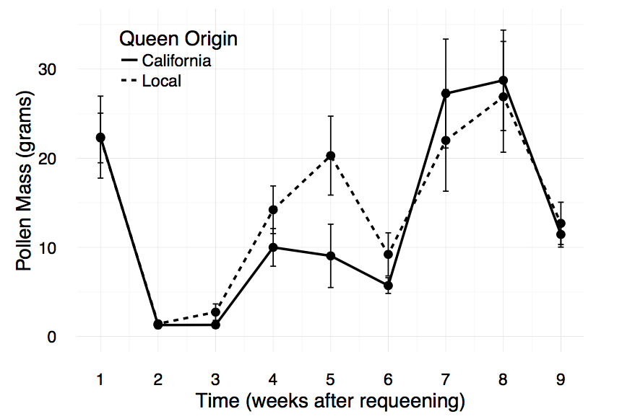

**Fig. 1** Average mass (g) of pollen collected by local and Californian foragers during weekly 24-hour pollen trapping periods. Colonies were treated with 1.11 specific gravity formic acid between the first and second samplings on 6 June 2016. Bars indicate standard error. Asterisks indicate significant values at the P≤0.05 level

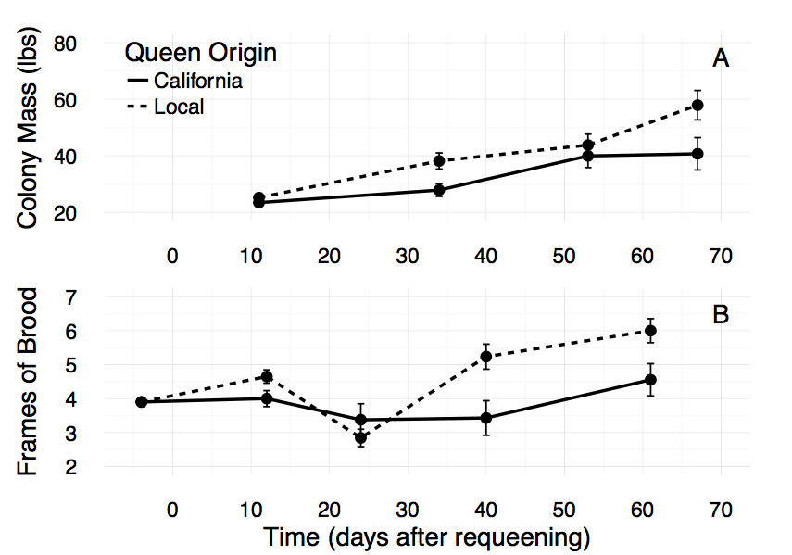

**Fig. 2 (A)** The curve of mean colony weight (lbs) of local and California colonies over time (days after requeening). We starting taking measurement on 14 June 2016, 11 days after we requeened the colonies.

**(B)** The curve of the mean number of brood frames in local and Californian colonies over time. The first time step (3.9 brood frames for both groups) was measured on 30 May 2016, four days before we requeened the colonies on 3 June 2016. Vorroa mites were treated for using formic acid between T2 and T3 on 6 June 2016. Bars indicate standard error. *Asterisks* indicate significant values at the P≤0.05 level

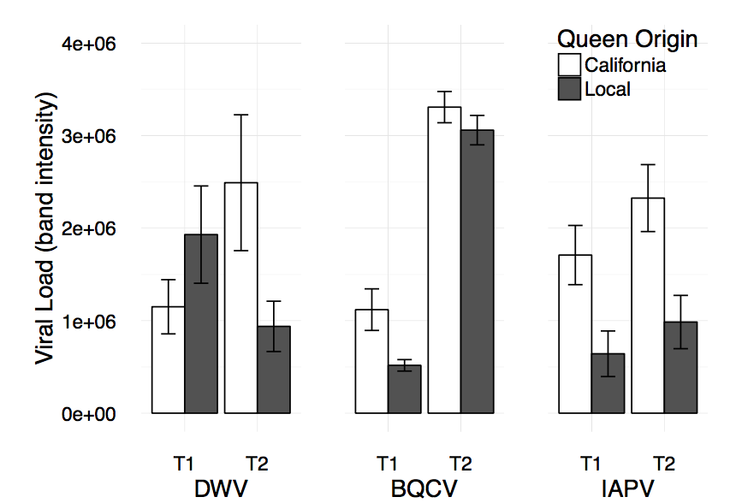

**Fig. 3** Levels (PCR band intensity) of DWV, BQCV, and IAPV in local and Californian colonies over two time steps. Fifty-bee samples at T1 were collected from the brood chamber on 15 June 2016 (12 days after requeening), and samples at T2 were collected on 13 July 2016 (40 days after requeening). Bars indicate standard error. *Asterisks* indicate significant values at the P≤0.05 level

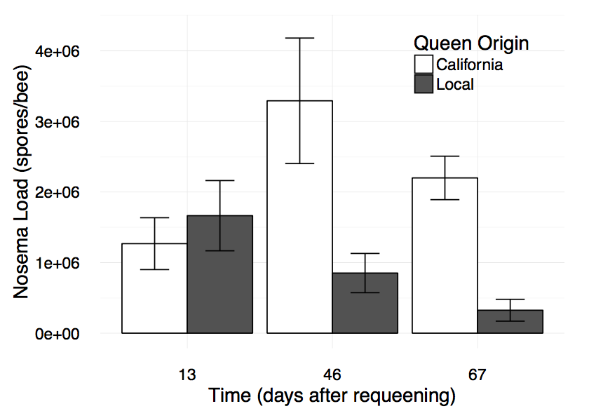

**Fig. 4** Mean *Nosema sp*. levels (spores per bee) in local and California colonies over time (days after requeening with the experimental queens). Fifty-bee samples were collected from peripheral nectar combs in each colony. Bars indicate standard error. *Asterisks* indicate significant values at the P≤0.05 level

**ACKNOWLEDGMENTS**

We would like to give a special thanks to the Levitt Center, the Casstevens family, the Hamilton College Dean of Students, and the Hamilton College Department of Biology for supporting and funding this study.

**LITERATURE CITED**

Antúnez, K., R. Martín-Hernández, L. Prieto, A. Meana, P. Zunino, and M. Higes. 2009. Immune suppression in the honey bee (Apis mellifera) following infection by Nosema ceranae (Microsporidia). Environmental microbiology 11:2284-2290.

Adams, J., Rothman, E. D., Kerr, W. E., & Paulino, Z. L. (1977). Estimation of the Number of Sex Alleles and Queen Matings from Diploid Male Frequencies in a Population of *Apis mellifera*. *Genetics*, *86*(3), 583–596

Berthoud, H., A. Imdorf, M. Haueter, S. Radloff, and P. Neumann. 2010. Virus infections and winter losses of honey bee colonies (Apis mellifera). Journal of Apicultural Research 49:60-65.

Botias, C., R. Martin-Hernandez, L. Barrios, A. Meana, and M. Higes. 2013. Nosema spp. infection and its negative effects on honey bees (Apis mellifera iberiensis) at the colony level. Veterinary research 44:25.

Bowen-Walker, P. L., and A. Gunn. 2001. The effect of the ectoparasitic mite, Varroa destructor on adult worker honeybee (Apis mellifera) emergence weights, water, protein, carbohydrate, and lipid levels. Entomologia Experimentalis et Applicata 101:207-217.

Brutscher, L. M., K. F. Daughenbaugh, and M. L. Flenniken. 2015. Antiviral defense mechanisms in honey bees. Current Opinion in Insect Science 10:71-82.

Buechler, R., C. Costa, F. Hatjina, S. Andonov, M. D. Meixner, Y. Le Conte, A. Uzunov, S. Berg, M. Bienkowska, M. Bouga, M. Drazic, W. Dyrba, P. Kryger, B. Panasiuk, H. Pechhacker, P. Petrov, N. Kezic, S. Korpela, and J. Wilde. 2014. The influence of genetic origin and its interaction with environmental effects on the survival of Apis mellifera L. colonies in Europe. Journal of Apicultural Research 53:205-214.

Cantwell, G.E. (1970) Standard methods for counting *nosema* spores. Am. Bee J. 110, 222–223.

Casteels, P., Ampe, C., Jacobs, F., Vaek, M., and Tempst, P. (1989) Apidaecins: antibacterial peptides from honeybees. *EMBO J* 8: 2387–2391.

Casteels, P., Ampe, C., Riviere, L., Van Damme, J., Elicone, C., Fleming, M., *et al.* (1990) Isolation and characterization of abaecin, a major antibacterial response peptide in the honeybee (*Apis mellifera*). *Eur J Biochem* 187: 381–386.

Casteels, P., Ampe, C., Jacobs, F., and Tempst, P. (1993) Functional and chemical of Hymenoptaecin, an antibacte- rial polypeptide that is infection-inducible in the honeybee (*Apis mellifera*). *J Biol Chen* 268: 7044–7054.

Casteels-Jonsson, K., Zhang, W., Capaci, T., Casteels, P., and Tempst, P. (1994) Acute transcriptional response of the honeybee peptide-antibiotics gene repertoire post- translational conversion of the precursor structures. *J Biol Chem* 269: 28569–28575.

Chaimanee, V., P. Chantawannakul, Y. Chen, J. D. Evans, and J. S. Pettis. 2012. Differential expression of immune genes of adult honey bee (Apis mellifera) after inoculated by Nosema ceranae. Journal of insect physiology 58:1090-1095.

Chen, Y. P., J. S. Pettis, M. Corona, W. P. Chen, C. J. Li, M. Spivak, P. K. Visscher, G. DeGrandi-Hoffman, H. Boncristiani, Y. Zhao, D. Vanengelsdorp, K. Delaplane, L. Solter, F. Drummond, M. Kramer, W. I. Lipkin, G. Palacios, M. C. Hamilton, B. Smith, S. K. Huang, H. Q. Zheng, J. L. Li, X. Zhang, A. F. Zhou, L. Y. Wu, J. Z. Zhou, M. Lee, E. W. Teixeira, Z. G. Li, and J. D. Evans. 2014. Israeli acute paralysis virus: epidemiology, pathogenesis and implications for honey bee health. Plos Pathogens 10:e1004261.

Chen, Y., J. D. Evans, L. Zhou, H. Boncristiani, K. Kimura, T. Xiao, A. M. Litkowski, and J. S. Pettis. 2009. Asymmetrical coexistence of *Nosema ceranae* and *Nosema apis* in honey bees. Journal of invertebrate pathology 101:204-209.

Costa, C., M. Lodesani, and K. Bienefeld. 2012. Differences in colony phenotypes across different origins and locations: evidence for genotype by environment interactions in the Italian honeybee (*Apis mellifera ligustica*)? Apidologie 43:634-642.

Coyne, V. E. 2011. The importance of ATP in the immune system of molluscs. Isj-Invertebrate Survival Journal 8:48-55.

de Miranda, J. R., and E. Genersch. 2010. Deformed wing virus. Journal of invertebrate pathology 103, Supplement:S61.

de Miranda, J. R., L. Bailey, B. V. Ball, P. Blanchard, G. E. Budge, N. Chejanovsky, Y. Chen, L. Gauthier, E. Genersch, D. C. de Graaf, M. Ribiere, E. Ryabov, L. De Smet, and van der Steen, Jozef J M. 2013. Standard methods for virus research in *Apis mellifera*. Journal of Apicultural Research 52:UNSP 52.4.22.

Delaplane, K. S., A. Dag, R. G. Danka, B. M. Freitas, L. A. Garibaldi, R. M. Goodwin, and J. I. Hormaza. 2013. Standard methods for pollination research with *Apis mellifera*. Journal of Apicultural Research 52:UNSP 52.4.12.

Dietemann, V., F. Nazzi, S. J. Martin, D. L. Anderson, B. Locke, K. S. Delaplane, Q. Wauquiez, C. Tannahill, E. Frey, B. Ziegelmann, P. Rosenkranz, and J. D. Ellis. 2013. Standard methods for varroa research. Journal of Apicultural Research 52:52.1.09.

Ding, S. 2010. RNA-based antiviral immunity. Nature Reviews Immunology 10:632-644.

Ding, S., and O. Voinnet. 2007. Antiviral immunity directed by small RNAs. Cell 130:413-426.

Dreller, C., R. E. Page, and M. K. Fondrk. 1999. Regulation of pollen foraging in honeybee colonies: effects of young brood, stored pollen, and empty space. Behavioral Ecology and Sociobiology 45:227-233.

Dussaubat, C., S. Sagastume, T. Gomez-Moracho, C. Botias, P. Garcia-Palencia, R. Martin-Hernandez, Y. Le Conte, and M. Higes. 2013. Comparative study of Nosema ceranae (Microsporidia) isolates from two different geographic origins. Veterinary microbiology 162:670-678.

Flenniken, M. L., M. Kunitomi, M. Tassetto, and R. Andino. 2010. The Antiviral Role of RNA Interference. Caister Academic Press, Wymondham; 32 Hewitts Lane, Wymondham Nr 18 0ja, England.

Free, J. B. 1967. Factors determining the collection of pollen by honeybee foragers. Animal Behaviour 15:134-144.

Gallai, N., J. Salles, J. Settele, and B. E. Vaissiere. 2009. Economic valuation of the vulnerability of world agriculture confronted with pollinator decline. Ecological Economics 68:810-821.

Galton, D. 1988. The Biology of the Honey Bee - Winston, ml. Tls-the Times Literary Supplement :288.

Gebremedhn, H., Tadesse, A., and Belay, T. 2014. Relating climatic factors to foraging behavior of honeybees (*Apis mellifera*) during blooming period of *Guizotia abyssinica* (L.F.). *Livestock Research for Rural Development. Volume 26, Article #60.*

Hetru, C., Hoffmann, D., and Bullet, P. (1998) Antimicrobial peptides from insects. In *Molecular Mechanisms of Immune Responses in Insects*. Brey, P.T., and Hultmark, D. (eds). London, UK: Chapman and Hall, pp. 40–66.

Higes, M., R. Martin, and A. Meana. 2006. Nosema ceranae, a new microsporidian parasite in honeybees in Europe. Journal of invertebrate pathology 92:93-95.

Higes, M., P. Garcia-Palencia, R. Martin-Hernandez, and A. Meana. 2007. Experimental infection of *Apis mellifera* honeybees with *Nosema ceranae* (Microsporidia). Journal of invertebrate pathology 94:211-217.

Higes, M., R. Martin-Hernandez, C. Botias, E. Garrido Bailon, A. V. Gonzalez-Porto, L. Barrios, M. Jesus del Nozal, J. L. Bernal, J. J. Jimenez, P. Garcia Palencia, and A. Meana. 2008. How natural infection by *Nosema ceranae* causes honeybee colony collapse. Environmental microbiology 10:2659-2669.

Higo, H. A., S. J. Colley, M. L. Winston, and K. N. Slessor. 1992. Effects of honey-bee (*Apis-mellifera* l) queen mandibular gland pheromone on foraging and brood rearing. Canadian Entomologist 124:409-418.

Holliday, R. 2006. Epigenetics A Historical Overview. Epigenetics 1:76-80.

Human, H., R. Brodschneider, V. Dietemann, G. Dively, J. D. Ellis, E. Forsgren, I. Fries, F. Hatjina, F. Hu, R. Jaffe, A. B. Jensen, A. Koehler, J. P. Magyar, A. Ozkyrym, C. W. W. Pirk, R. Rose, U. Strauss, G. Tanner, D. R. Tarpy, van der Steen, Jozef J M, A. Vaudo, F. Vejsnaes, J. Wilde, G. R. Williams, and H. Zheng. 2013. Miscellaneous standard methods for Apis mellifera research. Journal of Apicultural Research 52:UNSP 52.4.10.

Ihle, K. E., O. Rueppell, Z. Y. Huang, Y. Wang, M. K. Fondrk, R. E. Page Jr., and G. V. Amdam. 2015. Genetic architecture of a hormonal response to gene knockdown in honey bees. Journal of Heredity 106:155-165.

Klaudiny, J., Albert, S., Bachanová, K., Kopernicky, J., and Simúth, J. (2005) Two structurally different defensin genes, one of them encoding a novel defensin isoform, are expressed in honeybee *Apis mellifera*. *Insect Biochem Mol Biol* 35: 11–22.

Klee, J., A. M. Besana, E. Genersch, S. Gisder, A. Nanetti, D. Q. Tam, T. X. Chinh, F. Puerta, J. M. Ruz, P. Kryger, D. Message, F. Hatjina, S. Korpela, I. Fries, and R. J. Paxton. 2007. Widespread dispersal of the microsporidian *Nosema ceranae*, an emergent pathogen of the western honey bee, *Apis mellifera*. Journal of invertebrate pathology 96:1-10.

Kralj, J., and S. Fuchs. 2010. *Nosema sp* influences flight behavior of infected honey bee (Apis mellifera) foragers. Apidologie 41:21-28.

Lamberty, M., Ades, S., Uttenwiler-Josehp, S., Brookharts, G., Bushey, D., Hoffman, J.A., and Bulet, P. (1999) Insect immunity: isolation from the lepidopteran *Heliothis vire- scens* of a novel insect defensin with potent antifungal activity. *J Biol Chem* 274: 9320–9326.

Lovallo, N.C., and Cox-Foster, D.L. 1999. Alteration in FAD- glucose dehydrogenase activity and hemocyte behaviour contribute to initial disruption of *Manduca sexta* immune response to *Cotesia congregata* parasitoids. *J Insect Physiol* 45: 1037–1048.

Malone, L. A., H. A. Giacon, and M. R. Newton. 1995. Comparison of the responses of some New Zealand and Australian honey bees (*Apis mellifera L*) *to Nosema apis* Z. Apidologie 26:495-502.

Murilhas, A. M. 2002. Varroa destructor infestation impact on *Apis mellifera carnica* capped worker brood production, bee population and honey storage in a Mediterranean climate. Apidologie 33:271-281.

Nelson, C. M., K. E. Ihle, M. K. Fondrk, R. E. Page Jr., and G. V. Amdam. 2007. The gene vitellogenin has multiple coordinating effects on social organization. Plos Biology 5:673-677.

Nunes, F. M. F., K. E. Ihle, N. S. Mutti, Z. L. P. Simoes, and G. V. Amdam. 2013. The gene vitellogenin affects microRNA regulation in honey bee (*Apis mellifera*) fat body and brain. Journal of Experimental Biology 216:3724-3732.

Palacios, G., J. Hui, P. L. Quan, A. Kalkstein, K. S. Honkavuori, A. V. Bussetti, S. Conlan, J. Evans, Y. P. Chen, D. vanEngelsdorp, H. Efrat, J. Pettis, D. Cox-Foster, E. C. Holmes, T. Briese, and W. I. Lipkin. 2008. Genetic analysis of Israel acute paralysis virus: Distinct clusters are circulating in the United States. Journal of virology 82:6209-6217.

Parker, R., A. P. Melathopoulos, R. White, S. F. Pernal, M. M. Guarna, and L. J. Foster. 2010. Ecological adaptation of diverse honey bee (*Apis mellifera*) populations. Plos One 5:e11096.

Pettis, J. S., and K. S. Delaplane. 2010. Coordinated responses to honey bee decline in the USA. Apidologie 41:256-263.

Robonson, G. E., and Page, R. E. 1989. Genetic determination of nectar foraging, pollen foraging, and nest-site scouting in honey bee colonies. Behavioral Ecology and Sociobiology 24:317-323.

Root, A. I. 1910. The ABC and XYZ of bee culture. AI Root Company.

Seitz, N., K. S. Traynor, N. Steinhauer, K. Rennich, M. E. Wilson, J. D. Ellis, R. Rose, D. R. Tarpy, R. R. Sagili, D. M. Caron, K. S. Delaplane, J. Rangel, K. Lee, K. Baylis, J. T. Wilkes, J. A. Skinner, J. S. Pettis, and D. vanEngelsdorp. 2016. A national survey of managed honey bee 2014-2015 annual colony losses in the USA. Journal of Apicultural Research 54:292-304.

Szabo, T. I., and Lefkovitch., L. P. Fourth generation of closed population honeybee breeding. 2. Relationship between morphological and colony traits. *Apidologie*, Springer Verlag, 1988, 19 (3), pp. 259-274.

Tarpy, D. R., and T. D. Seeley. 2006. Lower disease infections in honeybee (*Apis mellifera*) colonies headed by polyandrous vs monandrous queens. Naturwissenschaften 93:195-199.

Tarpy, D. R., D. vanEngelsdorp, and J. S. Pettis. 2013. Genetic diversity affects colony survivorship in commercial honey bee colonies. Naturwissenschaften 100:723-728.

Tentcheva, D., L. Gauthier, L. Bagny, J. Fievet, B. Dainat, F. Cousserans, M. E. Colin, and M. Bergoin. 2006. Comparative analysis of deformed wing virus (DWV) RNA in Apis mellifera and Varroa destructor. Apidologie 37:41-50.

Teresa Santillan-Galicia, M., B. V. Ball, S. J. Clark, and P. G. Alderson. 2010. Transmission of deformed wing virus and slow paralysis virus to adult bees (*Apis mellifera* L.) by Varroa destructor. Journal of Apicultural Research 49:141-148.

vanEngelsdorp, D., J. Hayes Jr., R. M. Underwood, and J. Pettis. 2008. A Survey of Honey Bee Colony Losses in the US, Fall 2007 to Spring 2008. Plos One 3:e4071.

vanEngelsdorp, D., J. D. Evans, C. Saegerman, C. Mullin, E. Haubruge, B. K. Nguyen, M. Frazier, J. Frazier, D. Cox-Foster, Y. Chen, R. Underwood, D. R. Tarpy, and J. S. Pettis. 2009. Colony Collapse Disorder: A Descriptive Study. Plos One 4:e6481.

Wang, X. H., R. Aliyari, W. X. Li, H. W. Li, K. Kim, R. Carthew, P. Atkinson, and S. W. Ding. 2006. RNA interference directs innate immunity against viruses in adult *Drosophila*. Science 312:452-454.

Weinstock, G. M., G. E. Robinson, R. A. Gibbs, K. C. Worley, J. D. Evans, R. Maleszka, H. M. Robertson, D. B. Weaver, M. Beye, P. Bork, C. G. Elsik, K. Hartfelder, G. J. Hunt, E. M. Zdobnov, G. V. Amdam, M. M. G. Bitondi, A. M. Collins, A. S. Cristino, H. M. G. Lattorff, C. H. Lobo, R. F. A. Moritz, F. M. F. Nunes, R. E. Page Jr., Z. L. P. Simoes, D. Wheeler, P. Carninci, S. Fukuda, Y. Hayashizaki, C. Kai, J. Kawai, N. Sakazume, D. Sasaki, M. Tagami, S. Albert, G. Baggerman, K. T. Beggs, G. Bloch, G. Cazzamali, M. Cohen, M. D. Drapeau, D. Eisenhardt, C. Emore, M. A. Ewing, S. E. Fahrbach, S. Foret, C. J. P. Grimmelikhuijzen, F. Hauser, A. B. Hummon, J. Huybrechts, A. K. Jones, T. Kadowaki, N. Kaplan, R. Kucharski, G. Leboulle, M. Linial, J. T. Littleton, A. R. Mercer, T. A. Richmond, S. L. Rodriguez-Zas, E. B. Rubin, D. B. Sattelle, D. Schlipalius, L. Schoofs, Y. Shemesh, J. V. Sweedler, R. Velarde, P. Verleyen, E. Vierstraete, M. R. Williamson, S. A. Ament, S. J. Brown, M. Corona, P. K. Dearden, W. A. Dunn, M. M. Elekonich, T. Fujiyuki, I. Gattermeier, T. Gempe, M. Hasselmann, T. Kadowaki, E. Kage, A. Kamikouchi, T. Kubo, R. Kucharski, T. Kunieda, M. D. Lorenzen, N. V. Milshina, M. Morioka, K. Ohashi, R. Overbeek, C. A. Ross, M. Schioett, T. Shippy, H. Takeuchi, A. L. Toth, J. H. Willis, M. J. Wilson, K. H. J. Gordon, I. Letunic, K. Hackett, J. Peterson, A. Felsenfeld, M. Guyer, M. Solignac, R. Agarwala, J. M. Cornuet, M. Monnerot, F. Mougel, J. T. Reese, D. Vautrin, J. J. Gillespie, J. J. Cannone, R. R. Gutell, J. S. Johnston, M. B. Eisen, V. N. Iyer, V. Iyer, P. Kosarev, A. J. Mackey, V. Solovyev, A. Souvorov, K. A. Aronstein, K. Bilikova, Y. P. Chen, A. G. Clark, L. I. Decanini, W. M. Gelbart, C. Hetru, D. Hultmark, J. Imler, H. Jiang, M. Kanost, K. Kimura, B. P. Lazzaro, D. L. Lopez, J. Simuth, G. J. Thompson, Z. Zou, P. De Jong, E. Sodergren, M. Csuroes, A. Milosavljevic, K. Osoegawa, S. Richards, C. Shu, L. Duret, E. Elhaik, D. Graur, J. M. Anzola, K. S. Campbell, K. L. Childs, D. Collinge, M. A. Crosby, C. M. Dickens, L. S. Grametes, C. M. Grozinger, P. L. Jones, M. Jorda, X. Ling, B. B. Matthews, J. Miller, C. Mizzen, M. A. Peinado, J. G. Reid, S. M. Russo, A. J. Schroeder, S. E. St Pierre, Y. Wang, P. Zhou, H. Jiang, P. Kitts, B. Ruef, A. Venkatraman, L. Zhang, G. Aquino-Perez, C. W. Whitfield, S. K. Behura, S. H. Berlocher, W. S. Sheppard, D. R. Smith, A. V. Suarez, N. D. Tsutsui, X. Wei, D. Wheeler, P. Havlak, B. Li, Y. Liu, E. Sodergren, A. Jolivet, S. Lee, L. V. Nazareth, L. Pu, R. Thorn, V. Stolc, T. Newman, M. Samanta, W. A. Tongprasit, C. Claudianos, M. R. Berenbaum, S. Biswas, D. C. de Graaf, R. Feyereisen, R. M. Johnson, J. G. Oakeshott, H. Ranson, M. A. Schuler, D. Muzny, J. Chacko, C. Davis, H. Dinh, R. Gill, J. Hernandez, S. Hines, J. Hume, L. Jackson, C. Kovar, L. Lewis, G. Miner, M. Morgan, N. Nguyen, G. Okwuonu, H. Paul, J. Santibanez, G. Savery, A. Svatek, D. Villasana, R. Wright, and Honeybee Genome Sequencing Consort. 2006. Insights into social insects from the genome of the honeybee *Apis mellifera*. Nature 443:931-949.

Yamauchi, H. 2001. Two novel insect defensin from larvae of the cupreous chafer, *Anomala cupra*: purification, amino acid sequences and antibacterial activity. *Insect Biochem Mol Biol* 32: 75–78.

Yang, B., G. Peng, T. Li, and T. Kadowaki. 2013. Molecular and phylogenetic characterization of honey bee viruses, Nosema microsporidia, protozoan parasites, and parasitic mites in China. Ecology and Evolution 3:298-311.

Zambon, R. A., V. N. Vakharia, and L. P. Wu. 2006. RNAi is an antiviral immune response against a dsRNA virus in *Drosophila melanogaster*. Cellular microbiology 8:880-889.